1. Convert the .png file to .jpg - <https://png2jpg.com/>
2. Download labelimg Windows_v1.8.0 version - <https://tzutalin.github.io/labelImg/>
3. Click on Open Dir and select the folder -
4. Click on CreateRectBox and create the bbox-

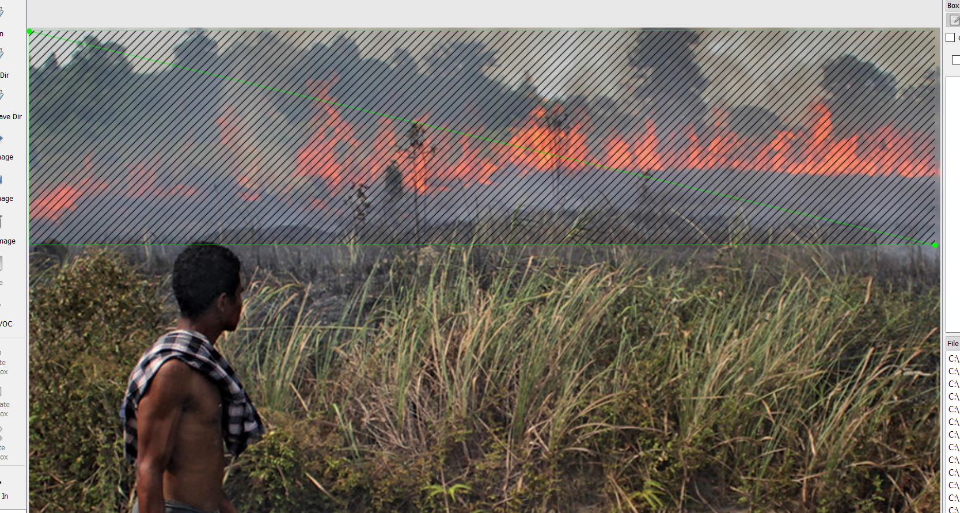

1. Give it label name fire- ***name it fire only as it is case sensitive***
2. Save the .xml file